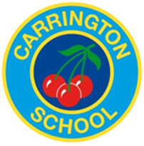
Carrington Junior School – Learning council
Meeting Friday 12th March 2021

Previous meeting:

Flow of meetings disrupted due to lockdown
Meeting:

Children from each class shared their views on being back in school.

“It’s fun to see friends again.”
“I like the normality of being back.”
“I like being at school. There are less distractions. At home my parents are always taking calls and my brothers annoy me.”
“ Home is boring but we do lots of different things here.”
“It means we can have 1:1 help if we are stuck.”
“ It doesn’t matter if the internet is tricky here.”
“ I liked having a relaxed timetable at home.”

We then talked about how remote learning could be even better in the future or for homework.

“ It would help to see teachers live for some lessons.”
“It’s harder to learn from home so the hours should be shorter.” Mrs Cameron told the council about the government guidelines.
“Sometimes I needed more explanations.” We talked about using the Mathletics help guides and asking parents. Mrs Cameron reminded us about the self help skills mat.
“ I would like 1:1 help if I get stuck.”
“A chat for help if we need it.” We talked about how lots of children used the teams chat to ask for help on questions. They decided this would be a good idea.
“Year 6 had daily meetings- this helped.” Lots of children agreed this would be a good idea.
Next meeting:

The learning council decided they would like to ask the following question to their class:

How could we improve remote learning for you if needed in the future / how it is used with homework?

