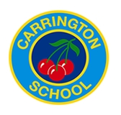

Complaint Form

Please complete and return to the Carrington Junior School Office by hand, post or email: office@carringtonjs.co.uk Marked CONFIDENTIAL. The School will acknowledge receipt and you explain what next actions will be taken.

Your name:
Pupil’s name (if relevant):

Your relationship to the pupil (if relevant):

Address:
Postcode:
Day time telephone number:
Evening telephone number:
Please give details of your complaint, including whether you have spoken to anybody at the school about it.

What actions do you feel might resolve the problem at this stage?

Are you attaching any paperwork? If so, please give details.

Signature:

Date:
Official use
Date acknowledgement sent:

By who:

Complaint referred to:

Date:

